**ASSIGNMENT-1**



ANNAPOORANA ENGINEERING COLLEGE

NAME : P.KARTHICK

CLASS : FINAL YEAR CSE

SUBJECT : IBM

REGISTER NO : 610219104011

DESIGN PART

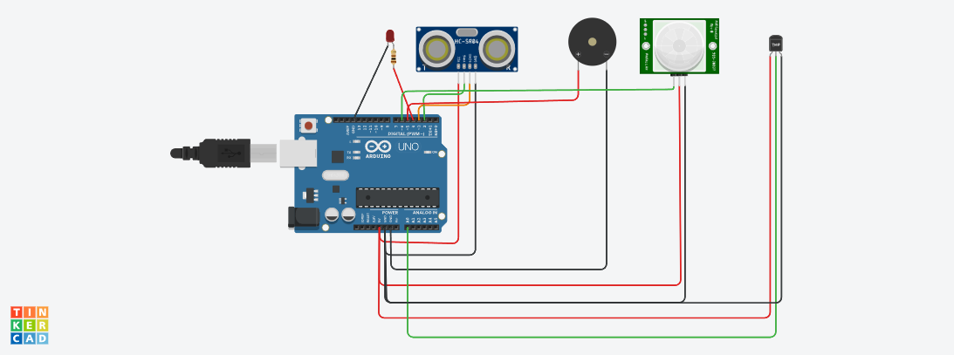

CODING

int t = 2;

int e = 3;

int led = 13;

int buzzer = 5;

int pir = 6;

int state = 0;

void setup()

{

pinMode(t, OUTPUT);

pinMode(e, INPUT);

pinMode(led,OUTPUT);

pinMode(pir,INPUT);

Serial.begin(9600);

}

void loop()

{

//code for finding distance between water in tank and the sensor

digitalWrite(t, LOW);

digitalWrite(t, HIGH);

delayMicroseconds(10);

digitalWrite(t, LOW);

float duration = pulseIn(e, HIGH);

float distance = (duration * 0.034) / 2;

Serial.print("Distance to take Tank full:");

Serial.println(distance);

//code for turning on buzzer and blinking led when tank is going to full

if(distance < 10)

{

Serial.print("Tank is full");

digitalWrite(led,HIGH);

delay(1000);

digitalWrite(led,LOW);

delay(1000);

tone(buzzer,450);

delay(1000);

noTone(buzzer);

delay(1000);

}

//code for identifying id any person is outside the door and turning on buzzer and led

state = digitalRead(pir);

delay(1000);

if (state == HIGH) {

digitalWrite(led, HIGH);

tone(buzzer,450);

delay(1000);

noTone(buzzer);

delay(1000);

Serial.println("Somebody is outside the door");

} else {

digitalWrite(led, LOW);

}

//code for measuring room temp

double a = analogRead(A0);

double t = (((a/1024)*5)-0.5)*100;

Serial.print("Room Temperature:");

Serial.println(t);

delay(1000);

}